Business Requirements Document(BRD) Template
Project/Initiative
Month 20YY
Version X.XX

Company Information

Document Revisions
Date | Version Number | Document Changes
05/02/20xx | 0.1 | Initial Draft

Approvals
Role | Name | Title | Signature | Date

Introduction

Project Summary

Objectives

Provide users with a secure and transparent online hotel booking process to increase customer trust and reduce booking abandonment.Enable users to complete hotel bookings online to increase the number of successful bookings.Improve the booking experience through clear pricing, secure payments, and timely confirmations to increase customer satisfaction and repeat bookings.

Background
[Provide a brief history of how the project came to be proposed and initiated, including the business issues/problems identified, and expected benefit of implementing the project/developing the product.]

Business Drivers
[List the business drivers that make development of this product important. These can be financial, operational, market or environmental.]

Project Scope
Users can search, book, and pay for hotel rooms online, and receive booking confirmation.

In Scope Functionality
- Hotel room selection.
- Booking information entry.
- Online booking payment.
- Booking price calculation.
- Display of services included in the booking price
- Display of the booking cancellation policy..
- Online payment using Apple Pay, Google Pay, and bank cards.
- Payment at the hotel (where supported).
- Temporary room reservation after a failed payment.
- Payment authorization (fund hold) before booking confirmation.
- Integration with a secure third-party payment gateway (Stripe or PayPal).
- Payment processing.
- Payment failure handling (e.g., insufficient funds or network connection issues).
- Booking status management.
- Automatic booking confirmation after successful payment.
- Automatic payment failure notification.
- Booking information storage.

Out of Scope Functionality
- Flight booking.
- Car rental.
- Loyalty program.
- Refund management.
- Cash payments.
- Bank transfer payments.
- Cryptocurrency payments.
- Installment payments.
- Payments using gift cards or vouchers.
- Payments using loyalty or reward points.
- Any functionality not explicitly listed in the In Scope Functionality.

System Perspective
[Provide a complete description of the factors that could prevent successful implementation or accelerate the projects, particularly factors related to legal and regulatory compliance, existing technical or operational limitations in the environment, and budget/resource constraints.]

Assumptions

Constraints

Risks

- .

Issues

Business Process Overview
[Describe how the current process(es) work, including the interactions between systems and various business units. Include visual process flow diagrams to further illustrate the processes the new product will replace or enhance.
Use case documentation and accompanying activity or process flow diagrams can be used to create the description(s) of the proposed or “To-Be” processes.]

Current Business Process (As-Is)
At any point during or after deployment of web apps or web sites (internal or external) to support business activities, development/support teams may create and deploy widgets.
- CMS / database administrators for the employee portal use the CMS tool to create widgets. They can test widgets in the designated staging environment, then register them and deploy to production.
- Development teams may deploy widgets to development and testing environments set up for their development projects. They must check widget code into and out of the source code repository according to their projects’ development schedule.
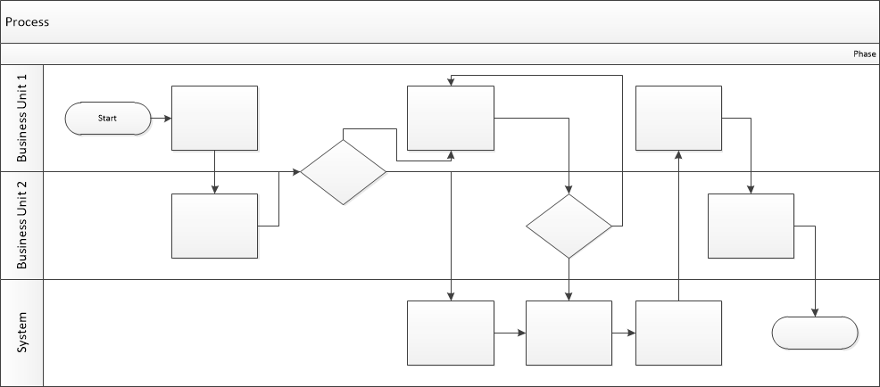

Proposed Business Process (To-Be)
- Technical Lead searches repository
- If widget is not found, user creates a new widget name record.
- WINS validates that all fields have been completed.
- WINS confirms that no similar widgets exist
- User confirms record to be created.
- User searches repository to locate existing widget description.
- WINS displays record
- User selects Edit to open and modify record
- WINS validates all fields completed correctly
- User confirms changes.
- WINS confirms changes and updates Audit table.

Stakeholder Requirements
SR-01
As a guest, I want to select a hotel room so that I can book accommodation that meets my needs and preferences.

SR-02
As a guest, I want to provide personal and contact information so that my reservation can be processed and confirmed.

SR-03
As a guest, I want to view the total booking cost, including room price, taxes, and additional fees so that I understand what I am paying for.

SR-04
As a guest, I want to view the services included in the booking price so that I know what is included in my booking before I pay.

SR-05
As a guest, I want to pay for the booking online so that I can complete my reservation quickly and securely.

SR-06
As a guest, I want my selected room to be held for 15 minutes after a failed payment so that another guest cannot book it while I retry the payment.

SR-07
As a guest, I want to view the booking cancellation policy so that I understand the cancellation terms before confirming my booking.

SR-08
As a guest, I want to view the payment status during payment processing so that I know whether my payment has been processed successfully.

SR-09
As a guest, I want to receive booking confirmation notifications so that I know my booking has been successfully confirmed.

SR-10
As hotel staff, I want to receive guest contact information and booking details so that I can prepare for the guest's arrival and manage the booking efficiently.

SR-11
As hotel staff, I want to receive guest comments and special requests so I can prepare for the guest's needs before arrival.

SR-12
As a TravelMate support agent, I want to track booking status and investigate booking issues so that I can resolve them quickly and efficiently.

The requirements in this document are prioritized as follows:
Value | Rating | Description
1 | Critical | This requirement is critical to the success of the project. The project will not be possible without this requirement.
2 | High | This requirement is high priority, but the project can be implemented at a bare minimum without this requirement.
3 | Medium | This requirement is somewhat important, as it provides some value but the project can proceed without it.
4 | Low | This is a low priority requirement, or a “nice to have” feature, if time and cost allow it.
5 | Future | This requirement is out of scope for this project, and has been included here for a possible future release.

Functional Requirements
Req# | Priority | Description | Rationale | Use Case Reference | Impacted Stakeholders
General / Base Functionality
FR-G-001 | 1 | The system shall allow users to search for and select an available hotel room. | Enable users to choose a suitable room. |  | Guest
FR-G-002 | 1 | The system shall display room information, including photos, ratings, reviews, and pricing. | Help users make informed booking decisions |  | Guest
FR-G-003 | 1 | The system shall allow users to enter personal and contact information required for booking | Collect information required to complete the booking. |  | Guest
FR-G-004 | 1 | The system shall calculate and display the total booking cost as the room price per night multiplied by the number of nights, plus applicable taxes and additional fees before payment | See a clear price before paying |  | Guest
FR-G-005 | 2 | The system shall display a clear list of services included in the booking price before payment. | See the services included in the price of the reservation |  | Guest
FR-G-006 | 2 | The system shall display the booking cancellation policy before the user confirms the booking. | To ensure users understand the cancellation terms before completing the booking. |  | Guest
FR-G-007 | 1 | The system shall allow users to select an available payment method. | Enable users to pay for bookings online. |  | Guest
FR-G-008 | 1 | The system shall support online payment using Apple Pay, Google Pay, and bank cards. | Provide users with convenient payment options |  | Guest
FR-G-009 | 2 | The system shall display the "Pay at Hotel" option only for hotels that support this payment method. | Allows the user to pay for the reservation in cash |  | Guest
FR-G-010 | 2 | The system shall support payment authorization (fund hold) before booking confirmation. | To reduce the risk of failed bookings and guarantee payment availability before confirmation |  | Guest
FR-G-011 | 1 | The system shall update the booking status throughout the booking process (Pending → Paid → Confirmed). | Track booking progress |  | Guest/Hotel staff
FR-G-012 | 2 | The system shall send a PDF booking confirmation to the user's email and display the booking details in the user's personal account immediately after successful payment. | Confirm successful booking |  | Hotel staff
FR-G-013 | 2 | The system shall reserve the selected room for 15 minutes after an unsuccessful payment attempt to allow the user to retry the payment. | Complete the booking after a failed payment attempt. |  | Guest
FR-G-014 | 3 | The system shall automatically notify the user when a payment attempt fails. | To inform the user that the payment was unsuccessful and allow them to retry the payment or choose another payment method. |  | Guest
Security Requirements
FR-S-001 | 3 | The system shall provide hotel staff with access to booking details, payment status, guest contact information, and special requests. | To enable hotel staff to manage bookings and assist guests efficiently. |  | Hotel staff
Reporting Requirements
FR-R-001 | - | - | - | - | -
Usability Requirements
FR-U-001 | 2 | The system shall display clear payment status messages during payment processing. | To keep guests informed about the payment process and reduce confusion. |  | Guest
FR-U-002 | 1 | The system shall display clear error messages if the payment fails due to insufficient funds or a network connection error. | To help guests understand the reason for the payment failure and take appropriate action. |  | Guest
Audit Requirements
FR-A-001 | 1 | The system shall record booking creation, payment attempts, payment results, and booking status changes. | To keep a record of booking activities. |  | Hotel Staff

Non-Functional Requirements
[Include technical and operational requirements that are not specific to a function. This typically includes requirements such as processing time, concurrent users, availability, etc.]
ID | Requirement
NFR-001 | The system must support at least 1000 concurrent booking requests.
NFR-002 | The booking and payment response time must be less than 2 seconds under normal load.
NFR-003 | The system availability must be at least 99.5%.
NFR-004 | The system must encrypt users' personal and payment data during transmission and storage.
NFR-005 | The system must not store users' CVV codes and must comply with the PCI DSS security standard.
NFR-007 | The booking confirmation email must be sent within 1 minute after successful payment.
NFR-008 | The system shall comply with the PCI DSS security standard.
NFR-009 | The system shall integrate with a secure third-party payment gateway (Stripe or PayPal) to process online payments.

Appendices

List of Acronyms
[If needed, create a list of acronyms used throughout the BRD document to aid in comprehension.]

Glossary of Terms
[If needed, identify and define any terms that may be unfamiliar to readers, including terms that are unique to the organization, the technology to be employed, or the standards in use.]

Related Documents
[Provide a list of documents or web pages, including links, which are referenced in the BRD.]

